**Administrator’s Guide**

1. Login to e-Dokyumento using ‘**administrator**’ as username and ‘**admin@123**’ for the password.

**Add Accounts:**

1. Click ‘Register’ from the Left side menu. Supply needed information and click ‘Register’ button to save.

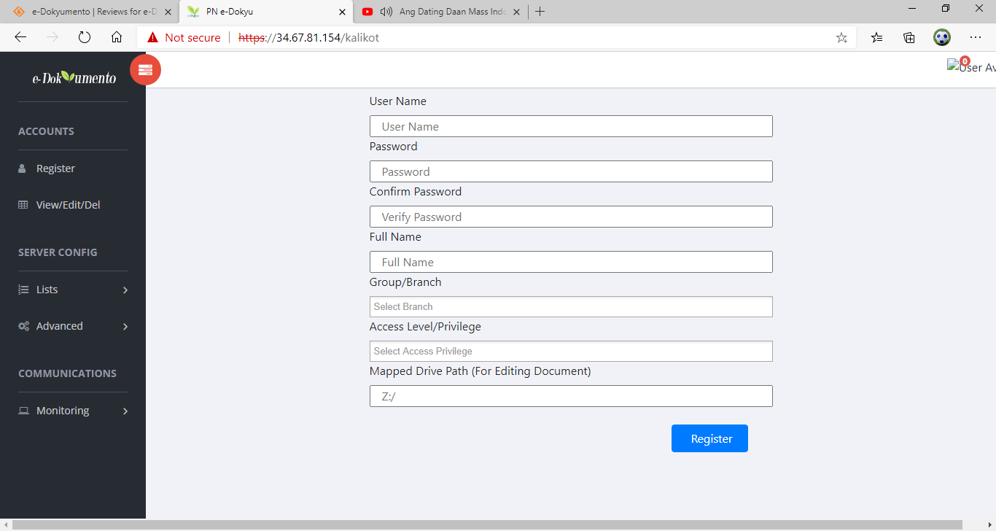

**View, Edit, and Delete Accounts:**

1. Click ‘View/Edit/Delete’ from the Left side menu. Click on trash icon to delete the user account. Click pencil icon to edit the user account.

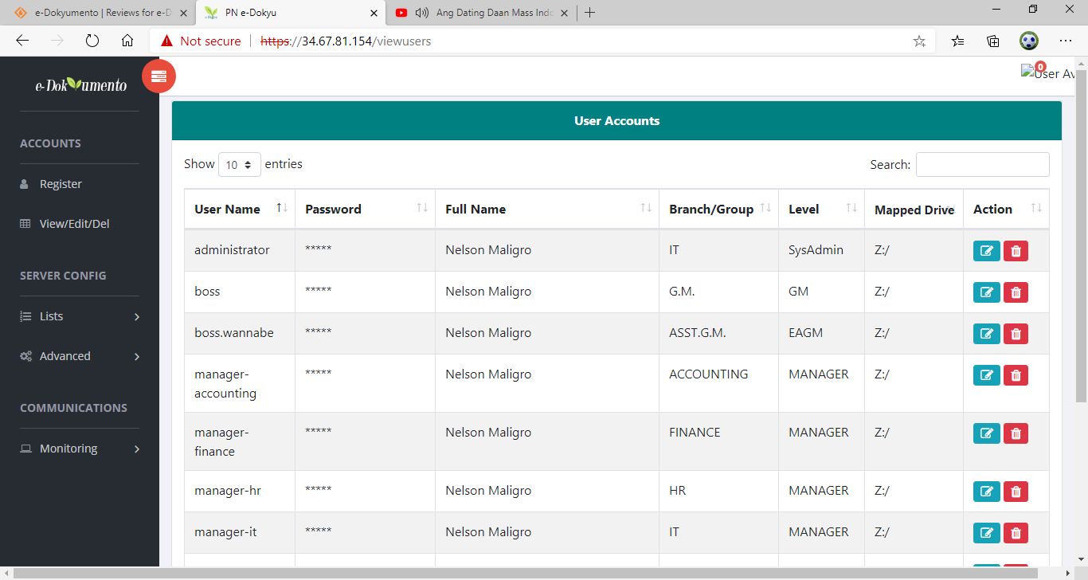

**Add and delete branches, departments, or groups:**

1. To add or delete departments, click ‘Lists’ then ‘Branches/Groups’. Select item in the ‘Group/Branch’ then click delete; or type-in name of Group or Department then click ‘add’ button.

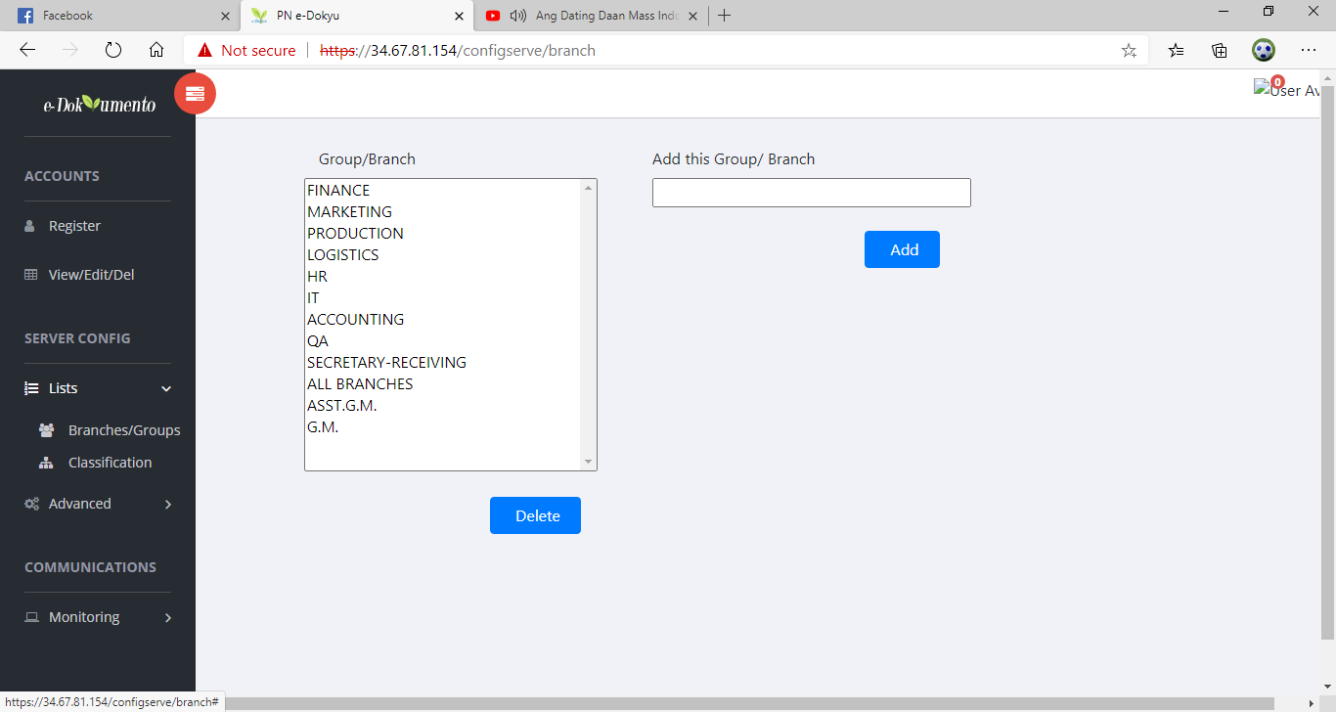

**Add and delete Correspondence classification:**

1. To add or delete correspondence classification, click ‘Lists’ then ‘Classification’. Select item in the ‘Classification’ then click delete; or type-in name of Correspondence classification then click ‘add’ button.

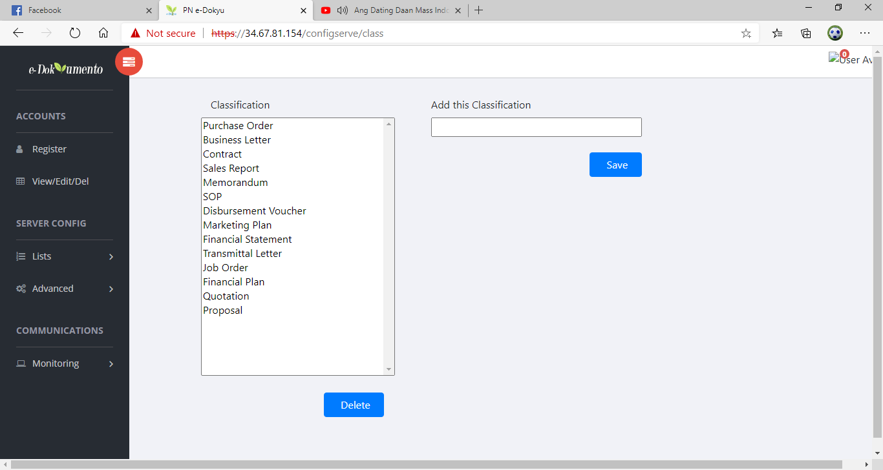

**Change the ‘Drive’ path:**

1. To change the default ‘Drive’ path of e-Dokyumento, click ‘Advanced’ then ‘Drive Path’.

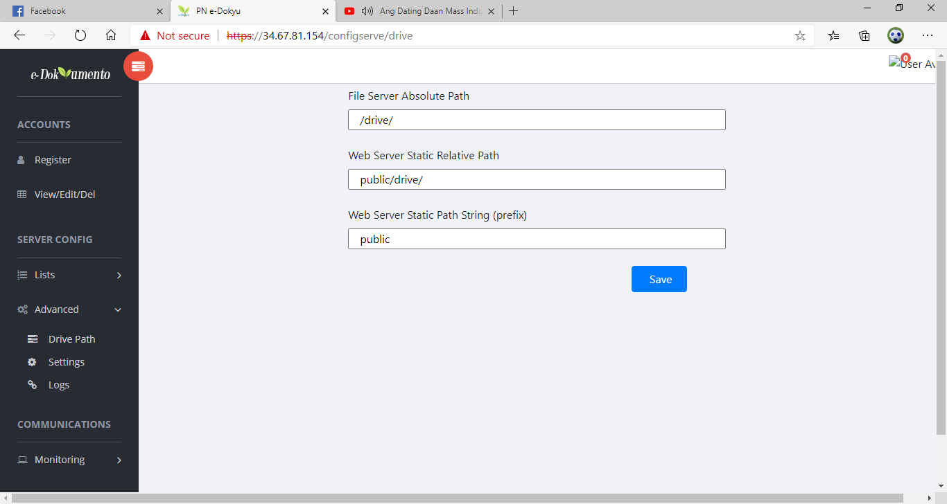

**Modify miscellaneous server settings:**

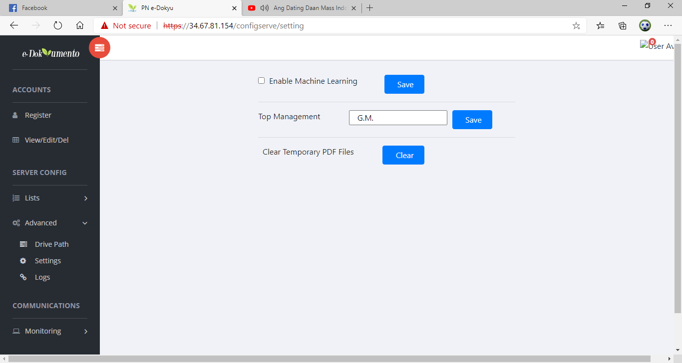

The top ‘Department/Branch’. This is important to provide default released folder for all endorsed documents from the Asst. GM.

This is to automatically classify documents.

It will be fully implemented on the next version

**Review logs including all signed documents:**

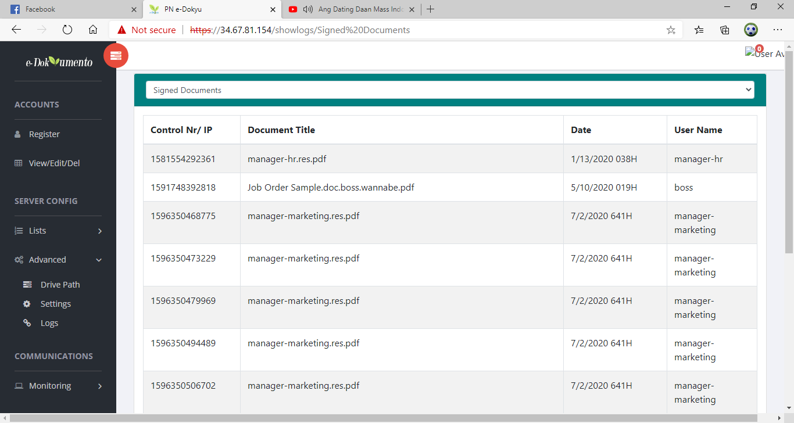

This will verify all signed documents through the control number

1. To modify or delete documents in the ‘Monitoring’, click monitoring, the ‘table’.

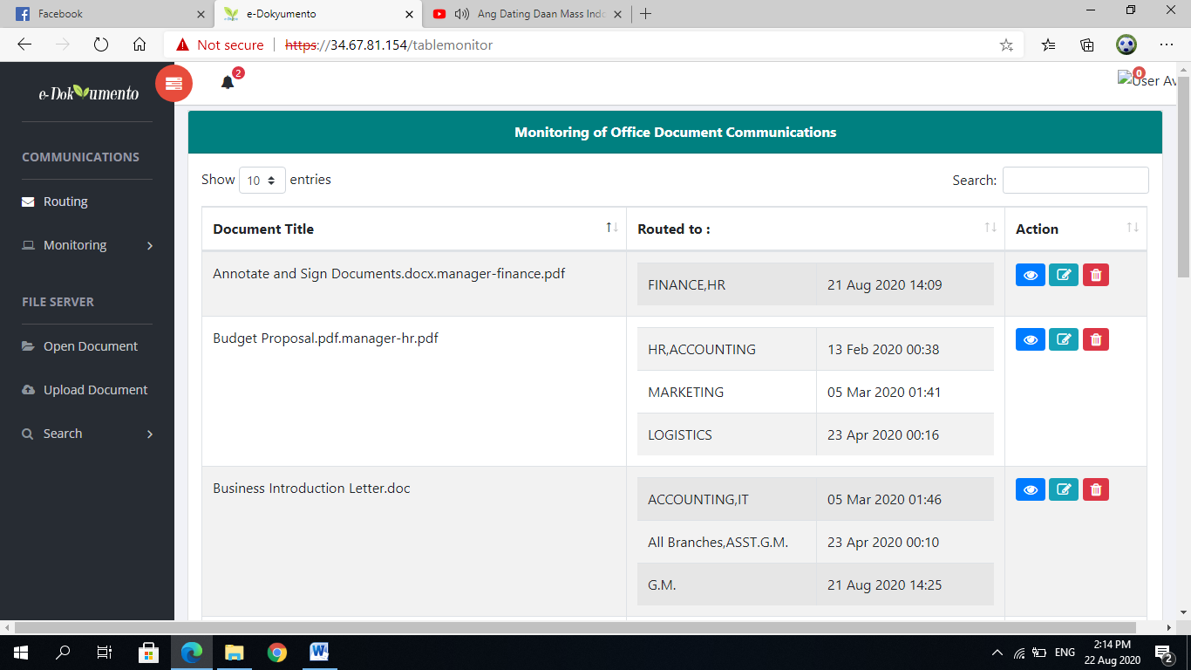

The administrator can delete any of these documents while other users can only delete documents originated from his/her department